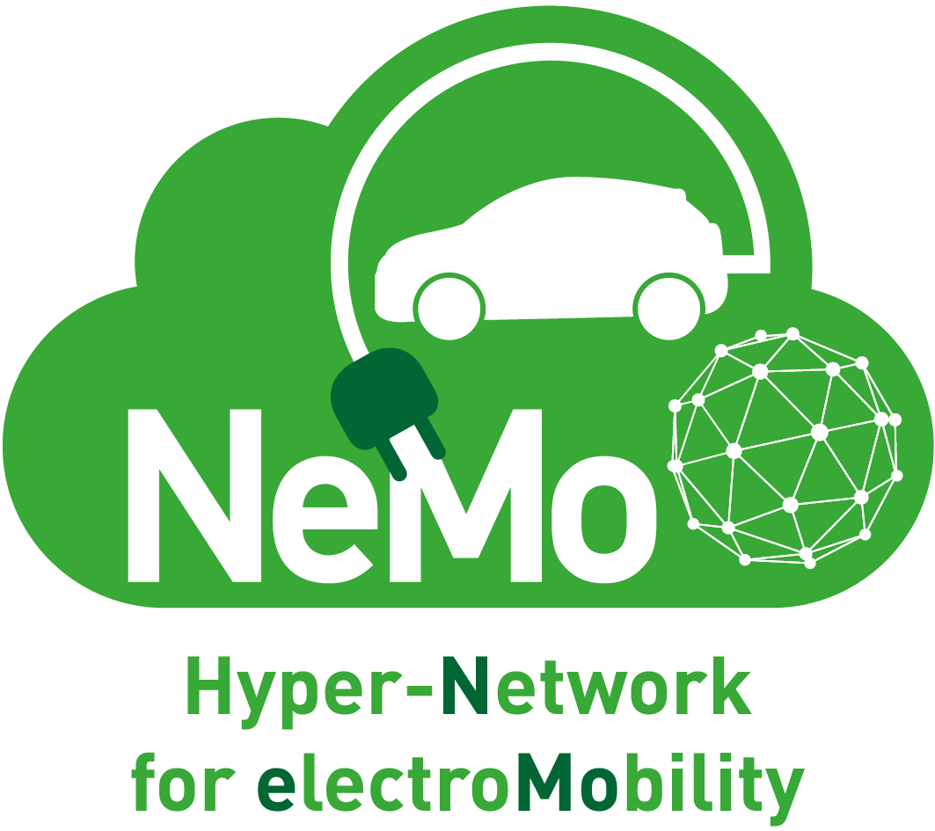 NeMo Associate Partner application form
Please fill out and return this form to Dr. Angelos Amditis, NeMo Project Coordinator, at a.amditis@iccs.gr
https://nemo-emobility.eu

Full legal name of your company/organisation: __________________________________________
Trading name / public name (if different from above): ____________________________________
Address: ______________________ City: _____________________ Country: ___________________
Telephone number: _______________________
Organisation website: ________________________
Contact person name: ________________________
Contact person email address: ________________________

Type of organisation:  ☐Public authority  ☐Infrastructure operator  ☐Service provider  ☐Industry  ☐Academic or research  ☐Association  ☐Other (please specify): | Do you currently provide electromobility services?  ☐Yes: Business to business (B2B)  ☐Yes: Business to client (B2C)  ☐Yes: Both B2B and B2C  ☐No, but plan to do so  ☐No, and no plans to do so.  If yes, please state which one(s) and in which country/countries or regions:

Do you currently use (purchase) electromobility services?
☐Yes
☐No, but plan to do so
☐No, and no plans to do so.

If yes, please state which one(s) and in which country/countries or regions: _____________

